**Lab 2**

**1. Write a program to calculate and print the factorial of a number using a for loop.**

**The factorial of a number is the product of all integers up to and including that**

**number, so the factorial of 4 is 4*3*2*1= 24.**

**Code:**

<?php

echo "Factorial of 5";

echo "</br>";

$facto=1;

for($i=1;$i<6;$i++){

$facto = $facto * $i;

}

echo $facto;

?>

**Output:**

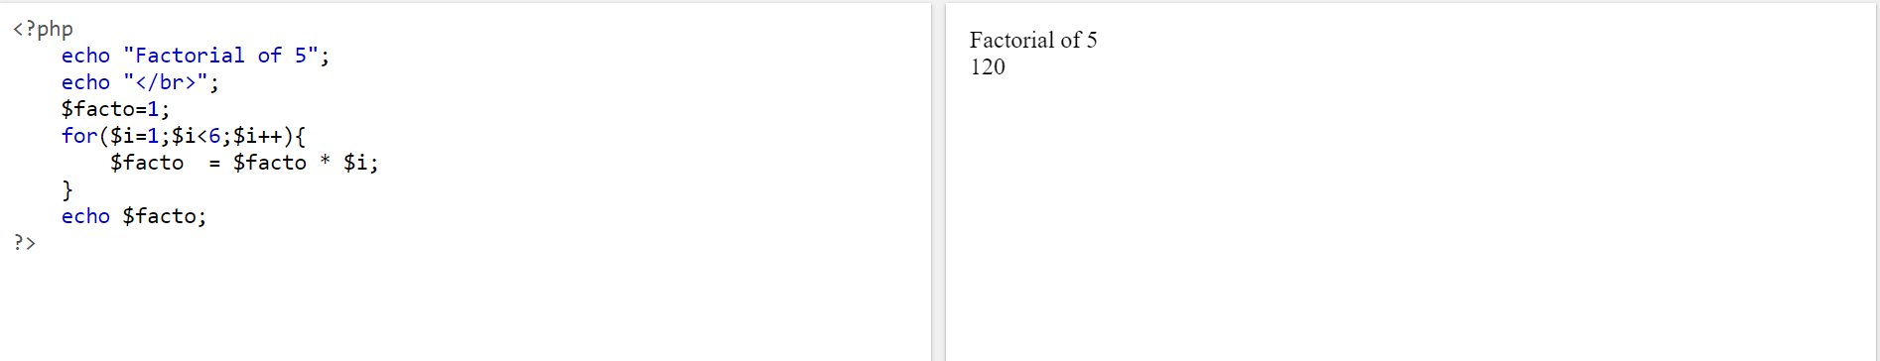

**2. Create a PHP script which display the capital and country name from the below array $ceu. Sort the list by the name of the capital.**

$ceu = array( "Italy"=>"Rome", "Luxembourg"=>"Luxembourg", "Belgium"=>

“Brussels", "Denmark"=>"Copenhagen", "Finland"=>"Helsinki", "France" => "Paris", "Slovakia"=>"Bratislava", "Slovenia"=>"Ljubljana", "Germany" => "Berlin", "Greece" =>"Athens", "Ireland"=>"Dublin", "Netherlands"=>"Amsterdam",

"Portugal"=>"Lisbon", "Spain"=>"Madrid", "Sweden"=>"Stockholm", "United

Kingdom"=>"London", "Cyprus"=>"Nicosia", "Lithuania"=>"Vilnius", "Czech

Republic"=>"Prague", "Estonia"=>"Tallin", "Hungary"=>"Budapest",

"Latvia"=>"Riga", "Malta"=>"Valetta", "Austria" => "Vienna", "Poland"=>"Warsaw") ;

**Sample Output:**

**The capital of Netherlands is Amsterdam**

**The capital of Greece is Athens**

**The capital of Germany is Berlin**

**Code:**<?php

$ceu = array( "Italy"=>"Rome", "Luxembourg"=>"Luxembourg", "Belgium"=>

"Brussels", "Denmark"=>"Copenhagen", "Finland"=>"Helsinki", "France" => "Paris",

"Slovakia"=>"Bratislava", "Slovenia"=>"Ljubljana", "Germany" => "Berlin", "Greece"

=>"Athens", "Ireland"=>"Dublin", "Netherlands"=>"Amsterdam",

"Portugal"=>"Lisbon", "Spain"=>"Madrid", "Sweden"=>"Stockholm", "United

Kingdom"=>"London", "Cyprus"=>"Nicosia", "Lithuania"=>"Vilnius", "Czech

Republic"=>"Prague", "Estonia"=>"Tallin", "Hungary"=>"Budapest",

"Latvia"=>"Riga", "Malta"=>"Valetta", "Austria" => "Vienna", "Poland"=>"Warsaw") ;

asort($ceu);

foreach($ceu as $x => $x_value) {

echo "The Capital of " . $x . " is " . $x_value;

echo "<br>";

}

?>

**Output:**

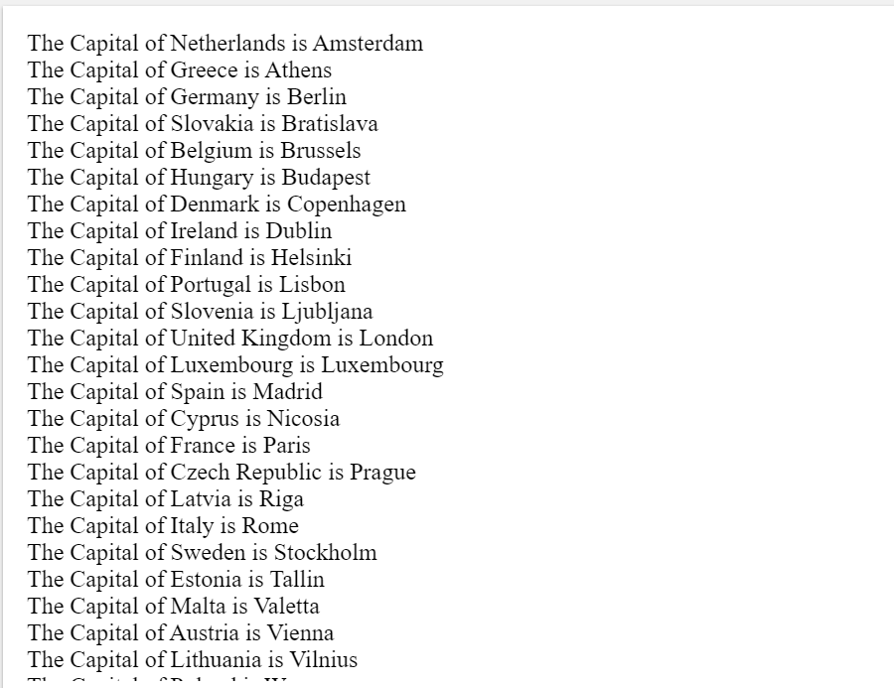

**3. Write a PHP script to calculate and display average temperature, five lowest and highest temperatures.**

**Recorded temperatures: 78, 60, 62, 68, 81, 68, 73, 85, 66, 64, 76, 63, 75, 76,**

**73, 68, 62, 73, 72, 65, 74, 62, 62, 65, 64, 68, 73, 75, 79, 73**

**Sample Output:**

**Average Temperature is : 69.77**

**List of five lowest temperatures : 60, 62, 63, 63, 64**

**List of five highest temperatures : 76, 78, 79, 81, 85**

**Code:**

<?php

$a = array(78, 60, 62, 68, 81, 68, 73, 85, 66, 64, 76, 63, 75, 76,

73, 68, 62, 73, 72, 65, 74, 62, 62, 65, 64, 68, 73, 75, 79, 73);

echo "Average = " . array_sum($a)/count($a) . "\n";

sort($a);

echo "<br>";

echo "List of five lowest temperatures : ";

$a = array_unique($a);

sort($a);

for($i=0;$i<5;$i++){

echo $a[$i]." " ;

}

echo "<br>";

rsort($a);

echo "List of five highest temperatures : ";

for($i=0;$i<5;$i++){

echo $a[$i]." " ;

}

?>

**Output:**

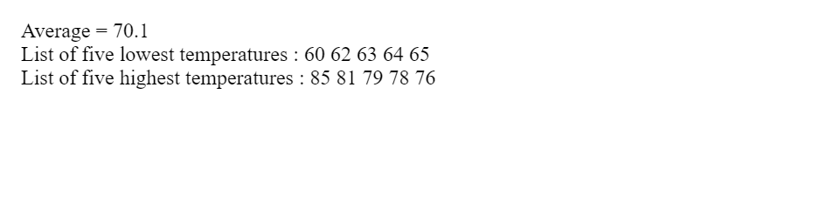

**4. Create a simple 'birthday countdown' script, the script will count the number of days between current day and your birth day.**

**Code:**

<?php

$birthdate = strtotime("12-09-2001");

$today = strtotime(date('Y-m-d H:i:s'));

$fixedBirthdate = date_create(date("Y", $today) . "-" . date("m", $birthdate) . "-" . date("d", $birthdate));

$diff = date_diff(date_create(date("d-m-Y", $today)), $fixedBirthdate);

echo $diff->format("%a days");

?>

**Output:**



**5. Write a script for your pair of arrays to find their union (all the elements),**

**intersection (elements in both, not just one), or difference (in one but not both).**

**Code:**

<?php

$arr1 = array('J','U','Z','A','R');

$arr2 = array('A','N','T','R','I');

$union = array_unique(array_merge($arr1,$arr2));

echo "UNION : ";

foreach($union as $i){

echo $i, " ";

}

$intersect = array_intersect($arr1,$arr2);

echo "<br>","INTERSECTION : ";

foreach($intersect as $i){

echo $i, " ";

}

$difference = array_diff($arr1,$arr2);

echo "<br>","ARRAY1 - ARRAY2 : ";

foreach($difference as $i){

echo $i, " ";

}

$difference = array_diff($arr2,$arr1);

echo "<br>","ARRAY2 - ARRAY1 : ";

foreach($difference as $i){

echo $i, " ";

}

?>

**Output:**



**6. Write a PHP function that checks whether a passed string is a palindrome or not?**

**A palindrome is word, phrase, or sequence that reads the same backward as**

**forward, e.g., madam or nurses run.**

**Code:**

<?php

$str="a b c b a";

function isPalindrome($str) {

if(!strcasecmp($str,strrev($str))){

return true;

}

return false;

}

if(isPalindrome($str)){

echo $str,' is a palindrome string';

}

else{

echo $str,' is not a palindrome string';

}

?>

**Output:** 